LAB Logbook

Lab 1
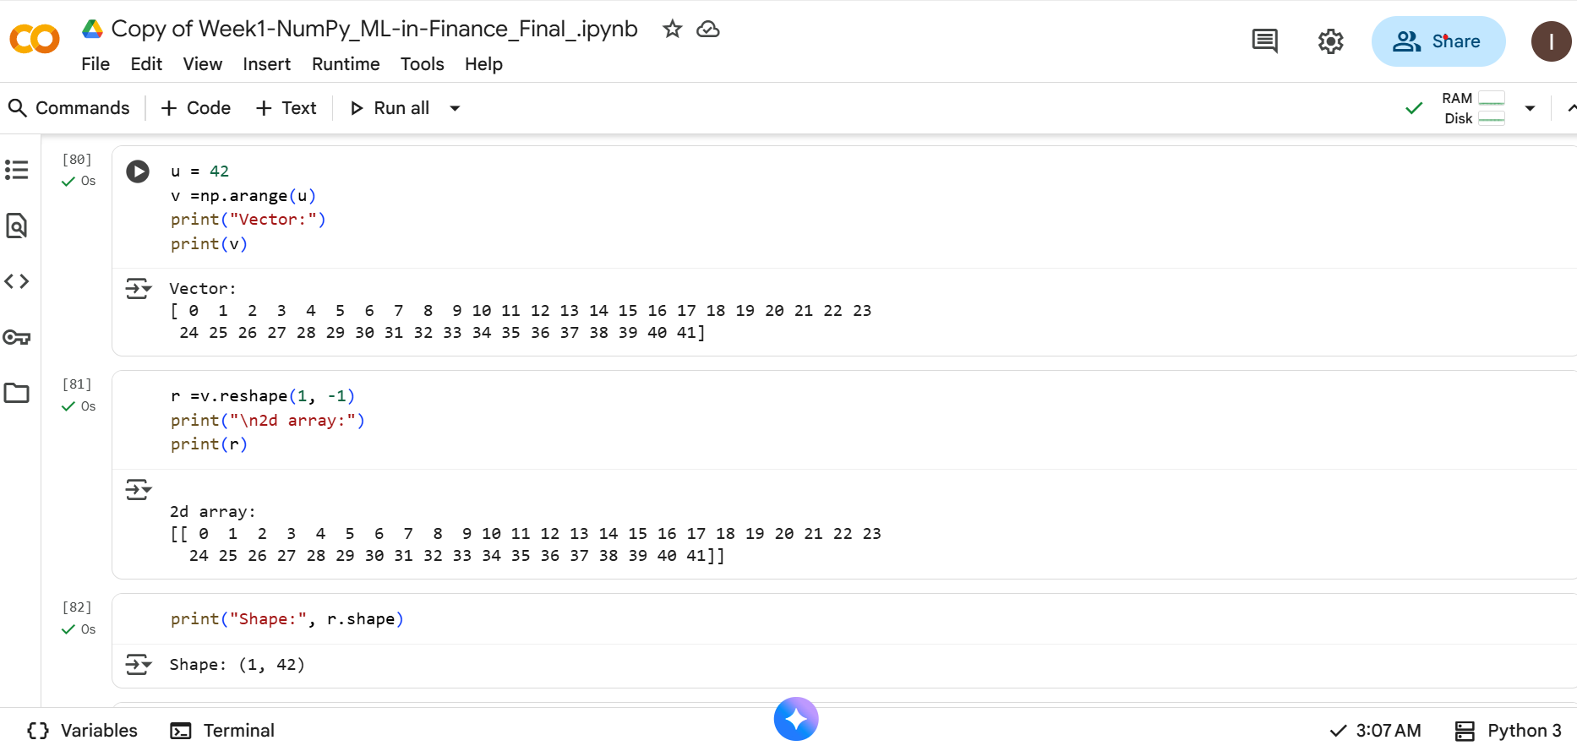
iankipchumba06-max/machine-learning-in-finance--assignment
Lab 2
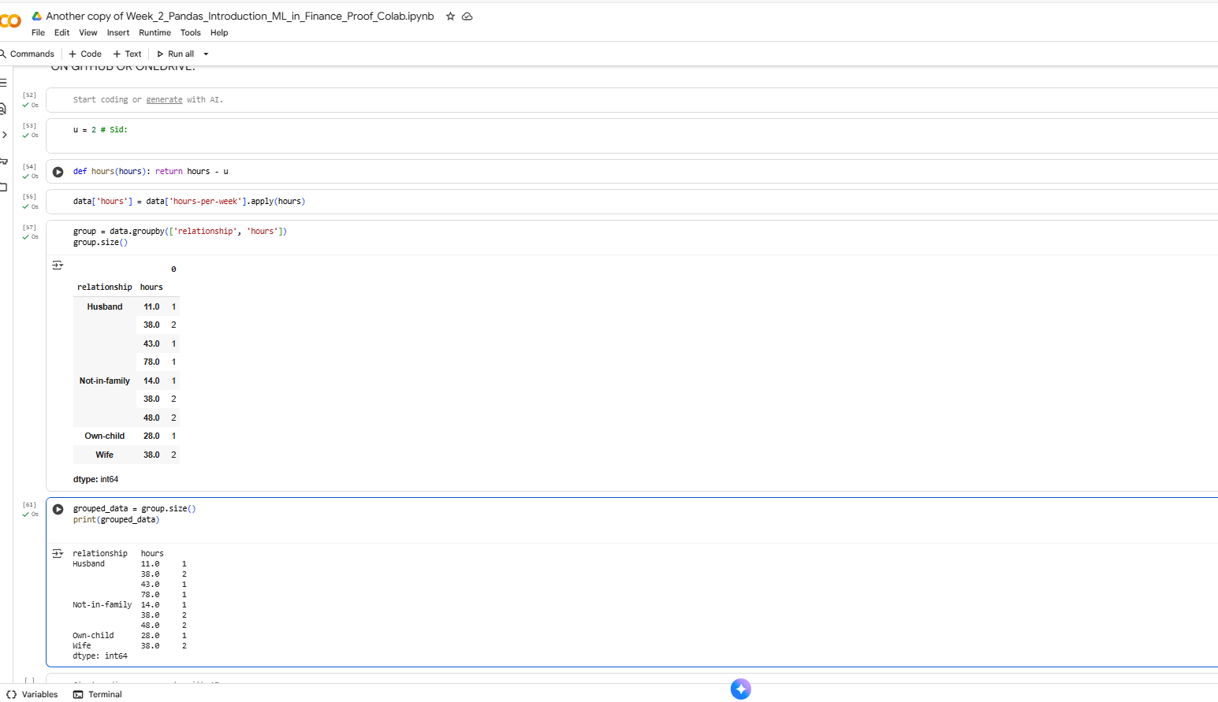
Another copy of Week_2_Pandas_Introduction_ML_in_Finance_Proof_Colab.ipynb - Colab

Lab 3
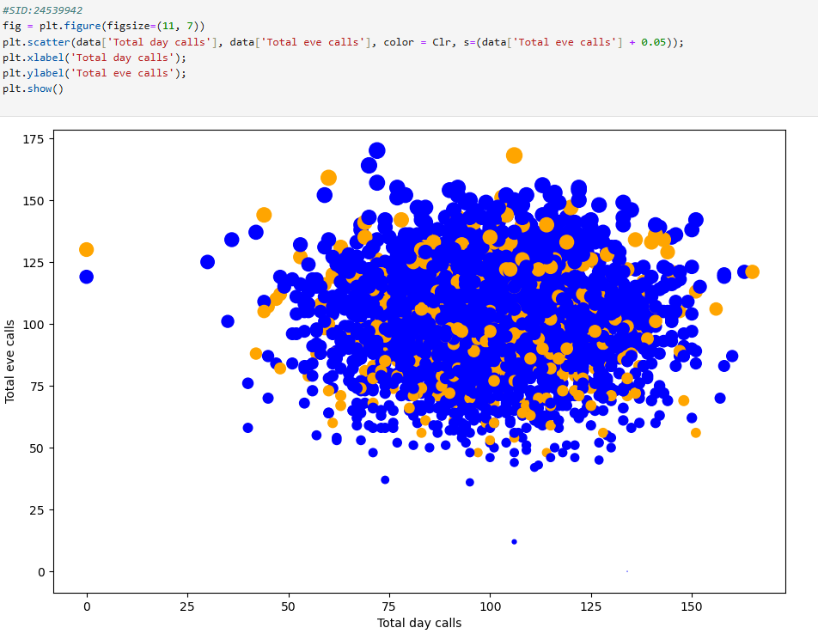
Week-3-Pandas-and-Seaborn_ML_in-Finance_Final
Lab 4
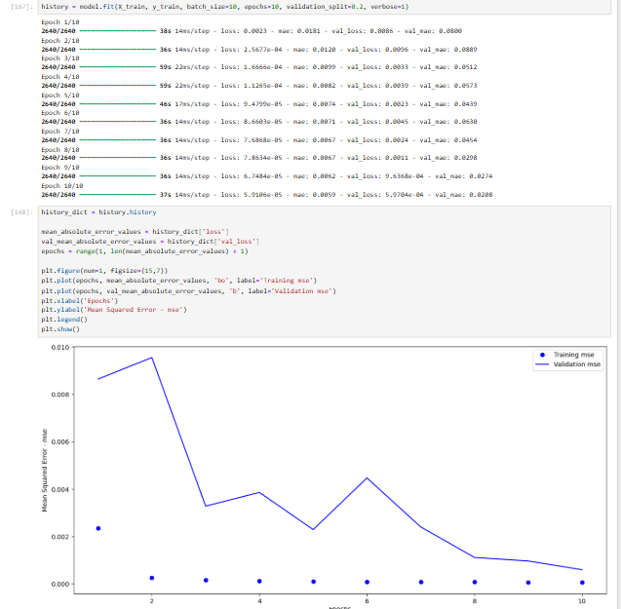

Week-4-MLP_S&P_ML_in-Finance_Final

Lab 5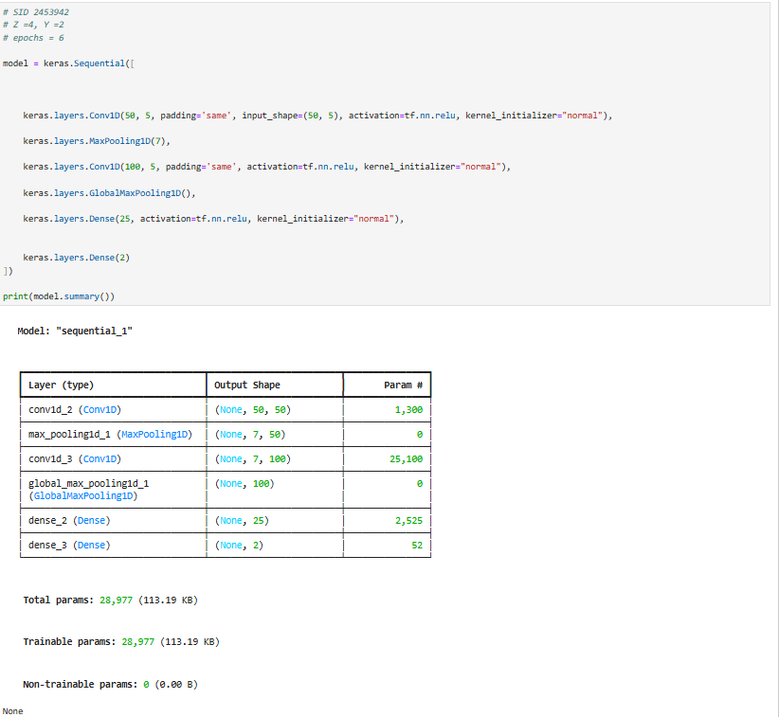
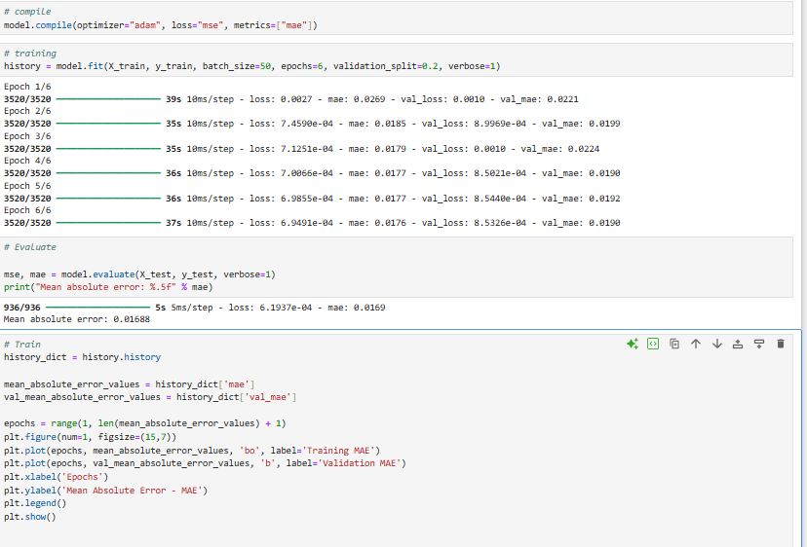
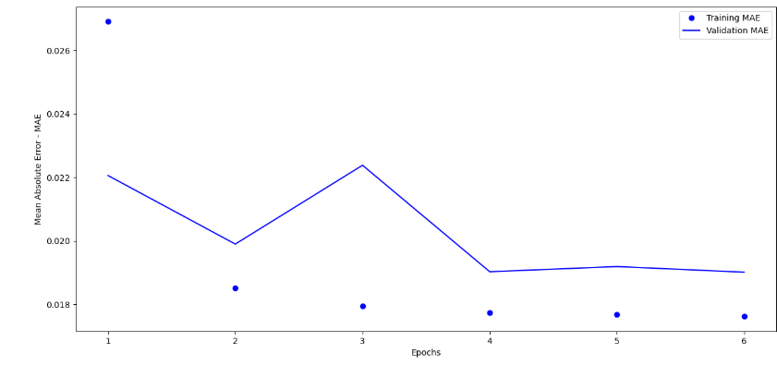
Week-5-CNN_EUR-USD_ML_in-Finance__Final
Lab 6

Lab 7

Lab 8

Lab 9

Lab 10

Lab 11

Lab 12

